# Fitness Training Center Management System

**Project Title:** Fitness Training Center Management System  
**Document Owner:** Business Data Analyst  
**Version:** 1.0  
**Date:** 17/06/2025

|  |  |
| --- | --- |
| 1.0 Introduction………………………………………………………………………………...  Table Of Contents | 4 |
| 1.1 purpose……………………………………………………………………………….......... | 4 |
| 1.2 Documentation Convention……………………………………………………………….. | 4 |
| 1.3 Intended Audience and Reading Suggestion………………………………………………. | 5 |
| 1.4 Product Scope……………………………………………………………………………… | 5 |
| 1.5 Reference………………………………………………………………………………....... | 6 |
| 2.0 Overall Description………………………………………………………………………... | 6 |
| 2.1 Product Perspective ……………………………………………………………………….. | 6 |
| 2.2 Product Function…………………………………………………………………………... | 6 |
| 2.3 User Classes and Characteristics …………………………………………………………. | 6 |
| 2.4 Operating Environment……………………………………………………………………. | 6 |
| 2.5 Design and Implementation Constraints ………………………………………………….. | 7 |
| 2.6 User Description…………………………………………………………………………… | 7 |
| 2.7 Assumptions and Dependencies…………………………………………………………… | 7 |
| 3.0 Extended Inference………………………………………………………………………… | 7 |
| 3.1 User Interfaces…………………………………………………………………………….. | 7 |
| 3.2 Hardware Interfaces………………………………………..……………………………… | 7 |
| 3.3 Software Interface………………………………………..………………………………... | 7 |
| 3.4 Communication Interfaces………………………………………………………………… | 8 |
| 4.0 Non-Functional Requirements………………………………………..…………………… | 8 |
| 4.1 Compatibility with Other Systems (Accounting and HR)………………………………… | 8 |
| 4.2 Scalability………………………………………………………………………………….. | 9 |
| 4.3 Secure Users’ Personal Data with Stakeholder Authorization…………………………….. | 9 |
| 4.4 Usability…………………………………………………………………………………… | 9 |
| 5.0 Use Case Specification and Use Case Diagram…………………………………………… | 10 |
| 5.1 Use Case Specification.………………………………………..…………………………... | 10 |
| 5.1.1 User Registration………………………………………..……………………………….. | 10 |
| 5.1.2 Manage Coach Schedule.………………………………………………………………... | 11 |
| 5.1.3 Tracking Coach Performance.…………………………………………………………… | 12 |
| 5.1.4 Managing User Personal Data…………………………………………………………… | 12 |
| 5.1.5 Update Coach Specification.………………………………………..…………………… | 13 |
| 5.1.6 Export Financial Reports.………………………………………………………………... | 13 |
| 5.1.7 Update Programs Using AI.……………………………………………………………... | 14 |
| 5.1.8 Schedule Sessions.………………………………………………………………………. | 15 |
| 5.1.9 Create Subscription………………………………………..…………………………….. | 16 |
| 5.1.10 Create Personal Member Programs.……………………………………………………. | 17 |
| 5.1.11 Manage Waitlist.………………………………………..……………………………… | 17 |
| 5.1.12 Apply Sessions Schedule Updates.…………………………………………………….. | 17 |
| 5.1.13 Send Subscription Canceling Warning.………………………………………………... | 18 |
| 5.1.14 Providing Coach Notes.………………………………………………………………... | 18 |
| 5.1.15 Sending Reminders Notification.………………………………………………………. | 19 |
| 5.2 Use Case Diagram.………………………………………..………………………………. | 20 |
| 6.0 Activity Diagrams.………………………………………..……………………………….. | 22 |
| 7.0 Class Diagram.………………………………………..…………………………………… | 35 |
| 8.0 Collaboration Diagrams.………………………………………..…………………………. | 36 |
| 9.0 Sequence Diagrams.………………………………………..……………………………… | 40 |
| 10.0 State Diagrams………………………………………..………………………………….. | 46 |

# Introduction

***1.1 purpose***

The purpose of this document is to present a detailed description of the Fitness Training Cetner Management System. It will explain the purpose and features of the system, the interfaces of the system, what the system will do, the constraints under which it must operate. This document is intended for both the stakeholders and the developers.

***1.2 Document Convention***

|  |  |
| --- | --- |
| **Terms** | **Definition** |
| Coach | A certified professional responsible for designing and delivering nutrition and workout programs to members. Coaches provide guidance, motivation, and feedback to help achieve fitness goals. |
| Member | An individual who has registered with the fitness center to access its facilities, classes, and services. Members may have different subscription types. |
| Fitness Training Cetner | A facility designed for individuals to engage in physical workouts and wellness activities. It may include equipment, classes, and professional coaches to support fitness goals. |
| Sessions | A single scheduled period during which members participate in a fitness activity, class, or one-on-one training with a coach. |
| Gymnasium | A space or facility equipped with exercise equipment and designated areas for physical training, group classes, or sports activities |
| Coach Feedback | A feature that allows coaches to review and track workout programs of a certain member. |
| Workout Program | Structured schedules designed to help individuals achieve specific fitness objectives. These may include exercises, durations, and progression strategies. |
| Nutrition Program | Personalized dietary recommendations provided to members to complement their fitness goals. These plans consider dietary preferences, caloric needs, and health conditions. |
| Workouts | Physical exercises designed to improve fitness levels, of many types in including: aerobic, yoga, HIIT(High Intensity Interval Training) |
| Waitlist | A list of members who want to join a fully booked class or session. Members on the waitlist are notified if spots become available. |
| Stakeholder | Any individual or group with an interest in the system, including members, coaches, administrators, and external partners (e.g., equipment suppliers or investors). |
| Center Administrators | An Admin (Administrator) is a user with elevated privileges in a system, responsible for overseeing and managing the operations of the fitness training center. Admins ensure that the system functions smoothly and efficiently by performing tasks |
| User | An Administrator or a Coach or a Member |
| Expenses | Costs incurred by the fitness center for operations, such as equipment maintenance, utility bills, staff salaries, and software subscriptions. |
| Subscription | Membership packages offered to members, defining the access level, duration, and included services. Examples include monthly, yearly, or pay-as-you-go subscriptions. |
| Permissions | Access rights assigned to users within a system, defining what actions they can perform. Permissions are crucial for maintaining security and operational control |
| Notifications | Alerts sent to members or coaches regarding session reminders, payment due dates, or system updates. |
| E-Payments | The digital transfer of funds through online or electronic systems. E-payments are widely used for transactions, allowing members to pay for subscriptions, classes, or services using variety of methods |
| AI Recommendations | Personalized suggestions for workouts, nutrition, or schedules based on member data and progress analysis. |
| Coach Specialization | Coach specialization refers to the specific areas of expertise or focus that a fitness coach possesses, such as strength training, yoga, HIIT (High-Intensity Interval Training), rehabilitation, or nutrition planning. |
| Database | A database is a structured and organized collection of data that allows for efficient storage, retrieval, and management of information. |

***1.3******Intended Audience and Reading Suggestions:***

Developers, project managers, marketing staff, users, testers, and documentation writers

As for the reading suggestions, the next chapter, the Overall Description section, of this document gives an overview of the functionality of the product. It describes the informal requirements and is used to establish a context for the technical requirements specification in the next chapter.

Then, the use cases specification and UML diagrams of this document is written primarily for the developers and describes in technical terms the details of the functionality of the product.

Both sections of the document describe the same software product in its entirety, but are intended for different audiences.

***1.4 Product Scope:***

This system, designed Fitness Training Center management, connects the Center administration with members and Coaches. It enables members to make payments through various methods, register for sessions, and track their booked sessions and subscriptions through a notification system. Coaches can monitor subscribed members, provide performance-related feedback, and create personalized workout and nutrition programs for each member, which are AI-generated and AI-updatable.

Additionally, the product offers user-friendly administrative tools tailored to center and staff management. These tools allow the administration to monitor expenses and payments (integrated with accounting systems), manage gymnasiums bookings and waitlists, and handle members' personal information and subscriptions. Coaches’ details, including specializations, schedules, and performance indicators, can also be managed and accessed (integrated with the HR system).

1***.5 References:***

IEEE. *IEEE Std 830-1998 IEEE Recommended Practice for Software Requirements Specifications.* IEEE Computer Society, 1998.

**2.0 Overall Description:**

***2.1 Product Perspective:***

The Fitness Training Center Management System is an integrated solution designed to enhance the operations of fitness centers. It acts as a centralized platform connecting administrators, coaches, and members. The system replaces traditional manual processes with automated features, integrating with accounting and HR systems. The product is self-contained but can connect with external systems like payment gateways and banks.

***2.2 Product Functions:***

The core functions of the system include:

* Member Management: Registration, subscription management, and profile maintenance
* Session Scheduling: Booking and managing workout sessions, gymnasiums and coaches in charge in addition to support waitlists.
* Personalized Plans: Coach and AI recommended workout and nutrition plans based on member data and updating plan based on coach notes.
* Coach Management: Tracking coach performance, schedules, and assigning members.
* Payment Processing: Supporting e-payments cash and credit cards in addition to generate financial reports.
* Notifications: Alerts for session reminders, subscription renewals, and updates.
* Members Progress Tracking: Evaluation coach notes and tracing member's level

***2.3 User Classes and Characteristics:***

* Members: Individuals who register to the fitness center and track their workout sessions and programs.
* Coaches: Certified professionals responsible for managing workout and nutrition programs.
* Administrators: Center in charge persons responsible for registering, managing , tracking members and coaches, scheduling session and accessing expenses reports.

***2.4 Operating Environment:***

* Hardware: Compatible with desktops, tablets, and smartphones.
* Operating System: Windows, macOS, iOS, and Android.
* Web Browser Support: Chrome, Firefox, Safari, and Edge (latest versions).
* Server Requirements: Cloud-based with high availability and fault tolerance.

***2.5 Design and Implementation Constraints:***

* Specify the limits of administrators, coaches and members’ permissions.
* Use standardized frameworks (e.g., React for frontend, Laravel for backend, Flutter for mobile app, MySQL for database).
* Integration with external accounting and HR systems.
* Scalability to support multiple fitness center branches.
* Usability Consideration for users with weak technical expertise.

***2.6 User Documentation:***

* User Manuals: Guides for members, coaches, and administrators.
* Online Help: Integrated help sections within the web and mobile apps.
* Tutorials: Video guides for key system features.
* Technical Documentation: API references and deployment guides for developers.

***2.7 Assumptions and Dependencies:***

* Members will have access to smartphones or computers.
* Reliable internet connectivity is assumed for system functionality.
* Dependences on third-party services like payment gateways and cloud hosting providers.
* The HR and accounting system must support API integration for seamless data exchange.
* A recommendation AI system must be coach on fitness training data and ready for integration.

**3.0 External Interface Requirements:**

***3.1 User Interfaces:***

* Members: Mobile app for subscription and sessions tracking.
* Coaches: Mobile app with tools for monitoring member progress and updating workout/nutrition plans.
* Administrators: Web dashboard for financial reports, user and coaches management and sessions scheduling.

***3.2 Hardware Interfaces:***

* Supporting Operating Systems: Windows 7^, macOS, and Linux, IOS 16 and Android 6^
* Supporting Device Types: PCs with multicore processors, 4GB^ RAM and sufficient storage. Smartphones with sufficient processor and ram
* Communication Methods: RESTful APIs over HTTPS

***3.3 Software Interfaces:***

1. Database Integration: The system uses relational databases (MySQL) to store and retrieve user profiles, session details, and AI-generated plans.

2. Payment Gateway Integration: Secure payment processing services (Stripe) for subscriptions or session bookings.

3. HR System Integration: The system connects with HR platforms (BambooHR) to handle coach data, including schedules, certifications, and metrics.

4. Accounting Tools Integration: Financial management tools (QuickBooks) for exporting financial reports about expenses

5. AI Integration: Recommendations AI system (B-Fit) for providing personalized recommendations for workouts and nutrition plans based on user progress and coach notes.

6. Messaging Services: Cloud messaging Services (Google Firebase) for sending notifications to keep members informed about schedules, bookings, and updates.

* 1. ***Communications Interfaces:***
* Protocols: Secure HTTP (HTTPS) for data transmission.
* Email Notifications: SMTP integration for alerts.
* Messaging Services: Twilio or similar for SMS reminders.
* Data Security: Encrypted communication (e.g., SSL/TLS).

**4.0 Non-Functional Requirements:**

***4.1 Compatibility with Other Systems (Accounting and HR):***

The system must integrate seamlessly with external systems such as accounting tools (e.g., QuickBooks, Xero) and HR platforms (e.g., BambooHR, Workday) to streamline workflows, enhance functionality, and reduce manual effort, this requires mainly:

* Data Exchange: Implement RESTful APIs or SOAP protocols to enable real-time data exchange with external systems and standardized data formats (e.g., JSON, XML) for compatibility.
* Accounting Integration: Sync financial data (e.g., payments, subscriptions, refunds) with accounting software, and generate and export detailed financial reports in compliance with local accounting standards.
* HR Integration: Manage coach schedules, payrolls, and certifications through integration with HR systems, and automatically update coach details (e.g., employment status, certifications).
* Error Handling: Handle integration failures gracefully with retry mechanisms and detailed error logging.
* Testing for Compatibility: Conduct end-to-end testing to ensure compatibility with different versions of accounting and HR systems.

***4.2 Scalability:***

The system must be able to handle increased loads as the fitness center grows, including more branches, members, coaches, and sessions, without significant performance degradation, this requires:

* Database Scalability: Use horizontal scaling techniques (e.g., sharding) to manage growing data volumes for user profiles, sessions, and subscriptions, and support partitioning to handle heavy read/write operations efficiently.
* Application Scalability: Deploy the system on a cloud-based platform (e.g., AWS, Azure, Google Cloud) to leverage elastic resources, and implement load balancers to distribute user requests across multiple servers.
* User Load: Support up to 10,000 concurrent users during peak hours with minimal response time (under 2 seconds).
* Session Management: Manage concurrent session scheduling and notification systems efficiently for multiple branches.
* Monitoring: Use tools like Prometheus or CloudWatch to monitor resource usage and system performance.
* Future Readiness: Ensure modular architecture to allow the addition of new modules or integrations (e.g., IoT fitness devices, analytics tools).

***4.3 Secure Users’ Personal Data with Stakeholder Authorization:***

The system must ensure the security of user data (e.g., personal details, medical history, and payment information) and enforce role-based access control (RBAC) for stakeholders like members, coaches, and administrators.

* Data Protection: Encrypt sensitive data in transit using TLS 1.3 and at rest using AES-256 encryption and comply with data privacy regulations like GDPR or HIPAA (if applicable).
* Authentication: Use secure login mechanisms (e.g., multi-factor authentication) for administrators and coaches.
* Role-Based Access Control (define access levels for each stakeholder):

-Members: Access their profile, subscription, and workout data only.

- Coaches: Access assigned members’ progress and schedules.

- Administrators: Full access to system operations and financial data.

* Audit Trails: Maintain detailed logs of all user actions (e.g., data updates, session bookings) for auditing and troubleshooting.
* Threat Detection: Use firewalls, intrusion detection systems (IDS), and regular penetration testing to identify vulnerabilities.
* Backup and Recovery: Implement daily automated backups and ensure recovery processes are tested to restore data within 1 hour of a failure.

***4.4 Usability:***

The system must be intuitive and user-friendly for all stakeholders (members, coaches, and administrators), minimizing the learning curve and enhancing productivity, this requires:

* User Interface Design: Design a clean and visually appealing UI using standard design principles (e.g., Material Design for web and mobile apps), and use consistent navigation patterns across the system to make it predictable for users.
* Accessibility: Ensure compliance with WCAG 2.1 Level AA standards to accommodate users with disabilities, and include features like screen readers, color contrast adjustments, and keyboard navigation.
* Mobile Usability: Optimize mobile apps for Android (6.0+) and iOS (16+)
* Feedback Mechanism: Provide an in-app feedback option for users to report issues or suggest improvements.
* Documentation and Tutorials: Offer detailed user manuals and video tutorials for members, coaches, and administrators, and integrate contextual help within the app (e.g., tooltips, FAQs).
* Error Messages: Display user-friendly error messages with clear instructions for resolution (e.g., "Invalid email format" instead of "Error 400").

**5.0 Use Case Specification and Use Case Diagram:**

|  |  |
| --- | --- |
| **Use Case ID** | UC-01 |
| **Use Case Name** | User Registration |
| **Actors** | Administrator, HR (for coach registering) |
| **Priority** | HIGH |
| **Description** | Create a new account for members or coaches by entering their personal data (ID number, name, age, gender, medical history, goals), certificates(coaches). |
| **Preconditions** | User doesn’t have already an account |
| **Postconditions** | User has created his account |
| **Normal Flow** | 1. Enter data    1. For members: personal data (ID number, name, age, gender, medical history, goals)    2. For coaches: personal data (ID number, name, age, gender, certificates) 2. Validate data 3. Create account 4. If the user is a coach, send his data to HR. 5. Giving user account’s id and password |
| **Alternative Flow** |  |
| **Exceptions** | 1. Invalid data 2. User already registered |
| **Assumptions** | 1. Valid age (15-80) 2. No critical diseases 3. Qualified coaches 4. User will subscribe |

|  |  |
| --- | --- |
| **Use Case ID** | UC-02 |
| **Use Case Name** | Manage Coach Schedule |
| **Actors** | Administrator |
| **Priority** | HIGH |
| **Description** | Managing coaches working hours, breaks, working days, holydays, logged in time, logged out time also connecting them to sessions schedule |
| **Preconditions** | Coach has already registered |
| **Postconditions** | A new schedule for the coach is registered to the system |
| **Normal Flow** | 1. Enter coach available working hours and days 2. Check center schedule 3. Connect coach schedule to sessions schedule 4. Coach Reviews the resulted schedule 5. Coach approves the schedule 6. Registering the final schedule |
| **Alternative Flow** | 1. Coach refuses the resulted schedule 2. Re-enter coach another available working hours and days 3. Coach rechecks the resulted schedule 4. If the coach working hours didn’t fit the center schedule the coach will be registered out of the center |
| **Exceptions** | 1. No session available 2. Coach’s working hours didn’t reach the required minimum working hours |
| **Assumptions** | 1. Coach has time to train 2. The administrator knows the coach specialization |

|  |  |
| --- | --- |
| **Use Case ID** | UC-03 |
| **Use Case Name** | Tracking Coach Performance |
| **Actors** | Administrator, HR, Cloud Messaging Service |
| **Priority** | LOW |
| **Description** | Tracking coaches by tracking their logged-in time, logged-out time, taken day-offs, commitment to breaks time |
| **Preconditions** | 1. Administrators have to be logged in. 2. Coach should have at least one active workout program during the current month. |
| **Postconditions** | 1. A Form sent to HR. 2. Success message to the Administrator. 3. Notification to the coach about. |
| **Normal Flow** | 1. Enter attended sessions, work days and notes about his performance. 2. Submit the performance form. |
| **Alternative Flow** |  |
| **Exceptions** |
| **Assumptions** | There should be members in the active workout programs for the wanted coach. |

|  |  |
| --- | --- |
| **Use Case ID** | UC-04 |
| **Use Case Name** | Managing User Personal Data |
| **Actors** | Administrator, Accounting |
| **Priority** | HIGH |
| **Description** | Administrators can view, update, or delete members' and coaches' personal data (ID number, name, age, gender, medical history, goals, certificates). |
| **Preconditions** | The user must already exist in the system. |
| **Postconditions** | Personal data is updated, deleted, or retrieved successfully. |
| **Normal Flow** | 1. Retrieve the personal data. 2. Make necessary edits or deletions. 3. Save the changes. |
| **Alternative Flow** | If the user doesn’t exist, research for the user again. |
| **Exceptions** | User doesn’t exist. |
| **Assumptions** | Personal data is entered correctly. |

|  |  |
| --- | --- |
| **Use Case ID** | UC-05 |
| **Use Case Name** | Update Coach Specifications |
| **Actors** | Administrator, HR, Cloud Messaging Service |
| **Priority** | HIGH |
| **Description** | Update or redefine coach qualifications, specialties, and certifications. |
| **Preconditions** | Coach account exists. |
| **Postconditions** | 1. Updates will be applied in the start of the next month. 2. Notify the coach and his members. |
| **Normal Flow** | 1. Modify or add coach qualifications, specialties, and certifications. 2. Save changes 3. Send Changes to HR. |
| **Alternative Flow** | Coach must provide another certificate. |
| **Exceptions** | 1. Invalid or outdated certifications. |
| **Assumptions** | 1. Certification details are correct. 2. The coach has experience in the updated specialization. 3. has approved on terms and conditions. 4. The coach must wait until the month ends. 5. The coach must update his schedule. 6. Related members must update their subscription data. |

|  |  |
| --- | --- |
| **Use Case ID** | UC-06 |
| **Use Case Name** | Export Financial Report |
| **Actors** | Administrator, Accounting |
| **Priority** | MEDIUM |
| **Description** | Export Financial report for expenses and profits by entering the date range (from date to date) the admin wishes to see the reports between |
| **Preconditions** | the admin must be logged in  The accounting department has already entered the operational expenses and subscriptions for given date |
| **Postconditions** |  |
| **Normal Flow** | 1. the Admin Enters the date range 2. validate the range 3. fetches the report from the accounting service 4. the system provides the financial reports |
| **Alternative Flow** | 1. Choose another date 2. revalidate 3. re-request the new report |
| **Exceptions** | The range date is invalid  The requested report has been not fully prepared yet |
| **Assumptions** | 1. the user must be admin 2. the admin must be authorized to see financial reports |

|  |  |
| --- | --- |
| **Use Case ID** | UC-07 |
| **Use Case Name** | Update programs using AI |
| **Actors** | AI, Coaches |
| **Priority** | HIGH |
| **Description** | The system uses AI to automatically update workout and nutrition programs for members based on their progress, performance data, and feedback from coaches. This ensures personalized and adaptive plans for members' fitness goals. |
| **Preconditions** | Member profile exists in the system with complete fitness data (e.g., goals, medical history, workout history).  Sufficient progress or performance data is available for analysis.  AI models for generating recommendations are active and trained.  new coach notes (optional) |
| **Postconditions** | 1. The updated program is saved in the system. 2. Members are notified of the updated plan. 3. Progress data is archived for future updates. |
| **Normal Flow** | 1. coach add or update the member progress and give notes on the member. 2. The AI retrieves the member’s progress, coach notes and past workout/nutrition data. 3. It analyzes the progress data, including completed sessions and performance metrics. 4. The AI generates updated recommendations for the workout and nutrition plans. 5. Coach validates the AI-generated recommendations with predefined fitness rules. 6. The updated program is saved to the member’s account. 7. Notifications are sent to the members about the updated program. |
| **Alternative Flow** | 1.1-If insufficient data exists for analysis:  1.2-The system requests additional input from the coach (e.g., recent activities or updated goals).  2- After receiving the required data, the AI reprocesses the update.  3.1if the coach rejected the updated program  3.2AI will regenerate another program. |
| **Exceptions** | 1. Invalid or incomplete progress data that cannot be processed. 2. coach rejected the updated program. |
| **Assumptions** | 1. coach regularly logs the member's progress data, such as completed workouts or dietary information. 2. Coaches timely give notes on member progress to improve AI recommendations. 3. The AI models are up-to-date, well-trained, and capable of handling diverse fitness requirements. 4. coach notes should be suitable for member. |

|  |  |
| --- | --- |
| **Use Case ID** | UC-08 |
| **Use Case Name** | Schedule sessions |
| **Actors** | Administrator |
| **Priority** | HIGH |
| **Description** | Scheduling sessions by specifying days, time of day, gymnasium, by adding new ones, update or deleting old ones |
| **Preconditions** | the admin must be logged in |
| **Postconditions** | 1. The session must be saved to the system DB 2. The center schedule will be updated at the start of the next month |
| **Normal Flow** | 1. System suggests available sessions to be scheduled 2. The admin chooses desired sessions from suggested ones 3. The sessions have been scheduled successfully |
| **Alternative Flow** | The admin should update or delete sessions ones to add new ones |
| **Exceptions** | No available sessions to be scheduled at all |
| **Assumptions** | The scheduled session should be suitable for the selected workout type by gymnasium |

|  |  |
| --- | --- |
| **Use Case ID** | UC-09 |
| **Use Case Name** | Create subscription |
| **Actors** | Administrator, Bank, Cloud Messaging Service |
| **Priority** | HIGH |
| **Description** | Subscribe to a member under a workout program in specific sessions, gymnasium and the coach. |
| **Preconditions** | 1. Members should already have an account in the system. 2. Administrators should be logged in. |
| **Postconditions** | 1. Linking members with the workout program with sessions, gymnasium and coach in the coach in system DB. 2. Send notification to members and coach. 3. Members will be subscribed in the workout program 4. The subscription cost will be withdrawn from the member budget. |
| **Normal Flow** | 1. Suggest to member workout program. 2. Choose the workout program. 3. Suggest sessions and coaches. 4. If the member chooses a specific coach, sessions will be suggested and vice versa. 5. Assign available gymnasium. 6. Ask members to verify the subscription result. 7. member approved. 8. Ask members to pay by available payment methods (e-wallet, credit card, cash). 9. Verify member sufficient money. 10. Give the member the subscription card, and the schedule. 11. Provide the bill. |
| **Alternative Flow** | 1.1 Member charges his e-wallet and try again.  1.2 pay cash instead.  2.1 Change workout program.  2.2 Add members to waitlist without paying by taking member name and phone number.  2.3 Cancel the process. |
| **Exceptions** | Not enough balance (when e-pay or credit-card method): Subscription is not available by the member chosen specifications |
| **Assumptions** | Valid age, health, gender for the workout program.   1. Members should have charged credit cards or charged e-wallet or sufficient cash. 2. No diseases prevent members from working out. 3. Members will attend the workout program. 4. E-bay systems are working effectively. |

|  |  |
| --- | --- |
| **Use Case ID** | UC-10 |
| **Use Case Name** | Create Personal member Programs |
| **Actors** | Coach, AI, Cloud Messaging Service |
| **Priority** | HIGH |
| **Description** | Generate personalized workout and nutrition program for members by AI. |
| **Preconditions** | Member profile newly created. |
| **Postconditions** | Recommendations are generated and displayed.  Notification with new recommended program for member will be sent.  Save recommended program to a member profile. |
| **Normal Flow** | 1. AI Retrieves the member’s profile and fitness data. 2. AI Analyzes goals and progress. 3. AI generates a workout and nutrition program. 4. Coach Approve the suggested plan. |
| **Alternative Flow** | AI Reanalyze and make a new program  coach reapprove the recommended program. |
| **Exceptions** | Coach rejected recommended program. |
| **Assumptions** | Member data is up to date. |

|  |  |
| --- | --- |
| **Use Case ID** | UC-11 |
| **Use Case Name** | Manage Waitlist |
| **Actors** | Timer, Cloud Messaging Service |
| **Priority** | MEDIUM |
| **Description** | The action of getting members from the waitlist queue and subscribe them in the wanted workout program. |
| **Preconditions** | There should be members on the waitlist. |
| **Postconditions** | Waitlist size will be updated in system DB. |
| **Normal Flow** | 1. Get the first enrolled member in the waitlist queue. 2. Check if there is a place in his workout program. 3. Send notification to members about his subscription availability. 4. Get the next member and repeat the process. |
| **Alternative Flow** | Keep the member on the waitlist and discuss the next member. |
| **Exceptions** | Subscription is still not available by the chosen specification. |
| **Assumptions** | 1. Valid age, and health for the workout program when popping up members. 2. No diseases prevent members from working out. 3. Members will attend the workout program. |

|  |  |
| --- | --- |
| **Use Case ID** | UC-12 |
| **Use Case Name** | Apply sessions schedule Updates |
| **Actor** | Timer, Cloud Messaging Service, NTP |
| **Priority** | HIGH |
| **Description** | update center's schedule |
| **Preconditions** | Server should sync with NTP Servers |
| **Postconditions** | Write about changes to system DB |
| **Normal Flow** | 1. Apply new sessions schedule updates to center schedule 2. Send notifications to admins and coach about the updated schedule |
| **Alternative Flow** |  |
| **Exceptions** | No updates to be applies |
| **Assumptions** | Sessions schedule already updated by admin |

|  |  |
| --- | --- |
| **Use Case ID** | UC-13 |
| **Use Case Name** | Send subscriptions canceling warning |
| **Actor** | Timer, NTP, Cloud Messaging Service |
| **Priority** | HIGH |
| **Description** | notify members about their canceled subscriptions |
| **Preconditions** | Server should sync with NTP Servers |
| **Postconditions** |  |
| **Normal Flow** | 1- Fetch Center members.  2-check if their subscription renewed.  3- Send notification to each member from them |
| **Alternative Flow** |  |
| **Exceptions** | Some users haven’t renewed their subscription. |
| **Assumptions** |  |

|  |  |
| --- | --- |
| **Use Case ID** | UC-14 |
| **Use Case Name** | providing coach notes |
| **Actors** | Coach |
| **Priority** | MEDIUM |
| **Description** | Providing notes about workout status of the member and nutrition status as well |
| **Preconditions** | 1. The member exists in the system 2. The member training under the supervision of this coach 3. The coach must be logged in |
| **Postconditions** | 1. The notes must be saved to the system DB 2. The Recommendation AI must be triggered to generate new programs |
| **Normal Flow** | 1. the coach enters the notes 2. save the notes |
| **Alternative Flow** | research with another name or id |
| **Exceptions** | The searched member not found |
| **Assumptions** | 1. The members must attend at least one session 2. The member must be attending sessions at the time |

|  |  |
| --- | --- |
| **Use Case ID** | UC-15 |
| **Use Case Name** | Sending reminders notification |
| **Actors** | Cloud Messaging Service, Timer |
| **Priority** | HIGH |
| **Description** | Automatically send notifications to members or coaches for reminders. |
| **Preconditions** | Notifications must be configured in the system. |
| **Postconditions** | Notifications are delivered successfully. |
| **Normal Flow** | 1. Check if the time hit predefined stored time. 2. Fetch users who already activated notification service. 3. Generate the notification content. 4. Send the notification. |
| **Alternative Flow** |  |
| **Exceptions** | No users activated their notification service. |
| **Assumptions** | Sent notification’s content are correct. |

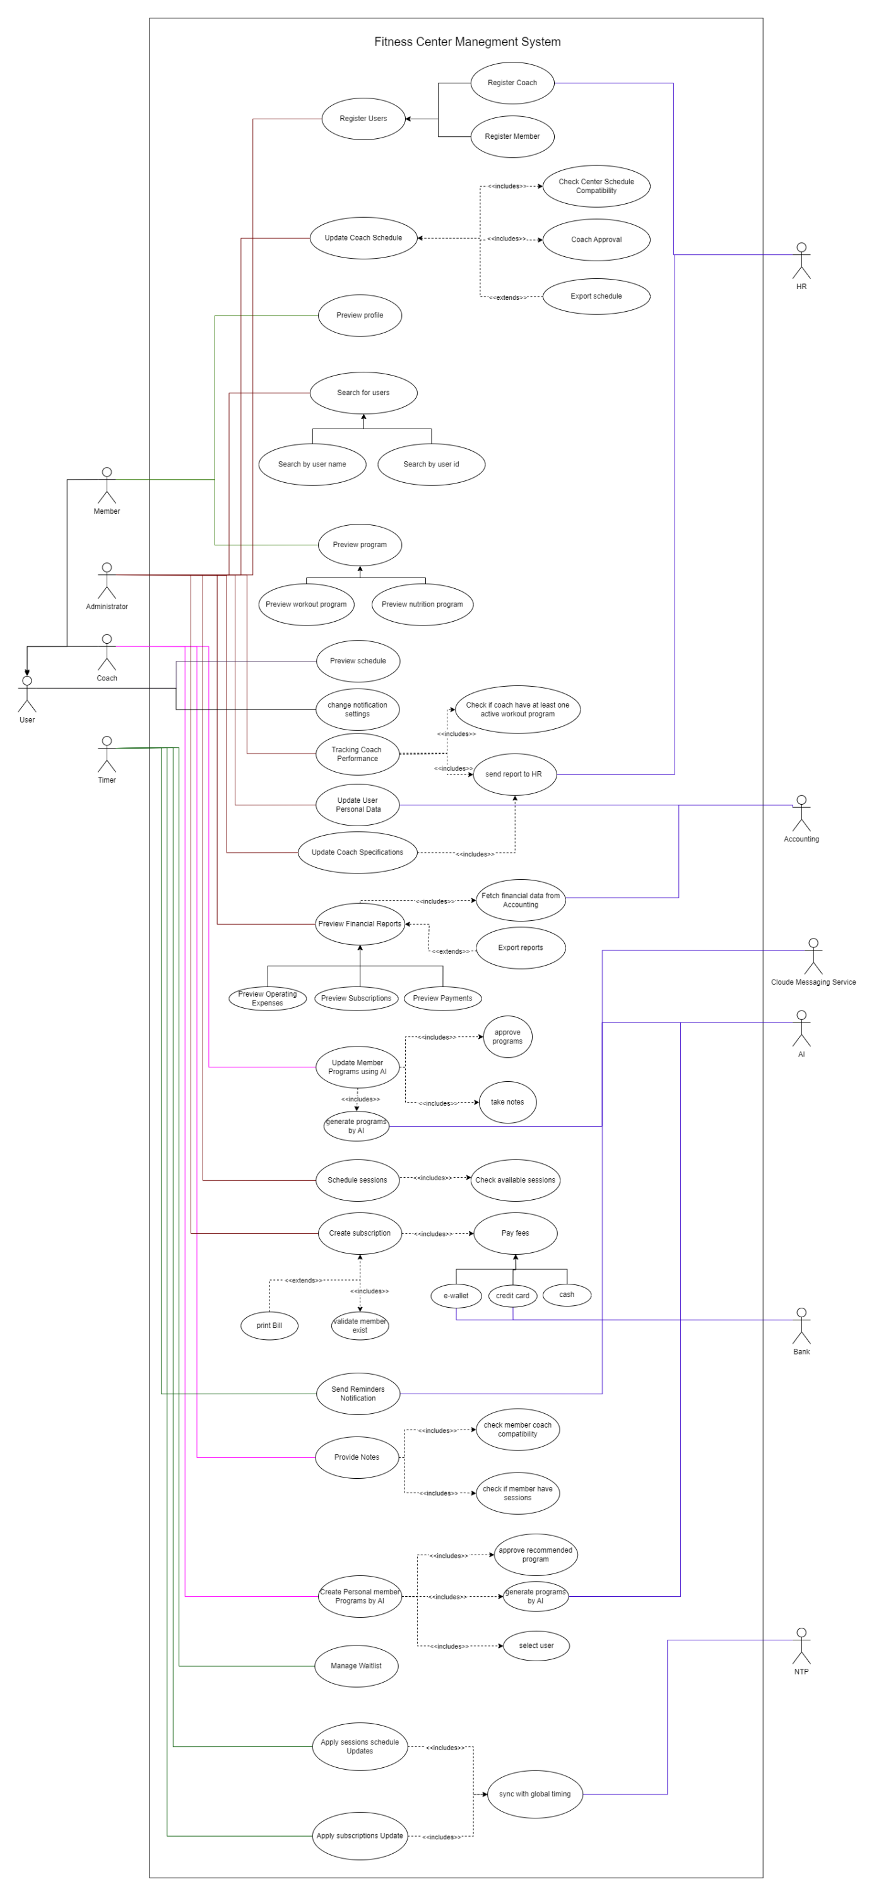



* 1. **Activity Diagrams:**

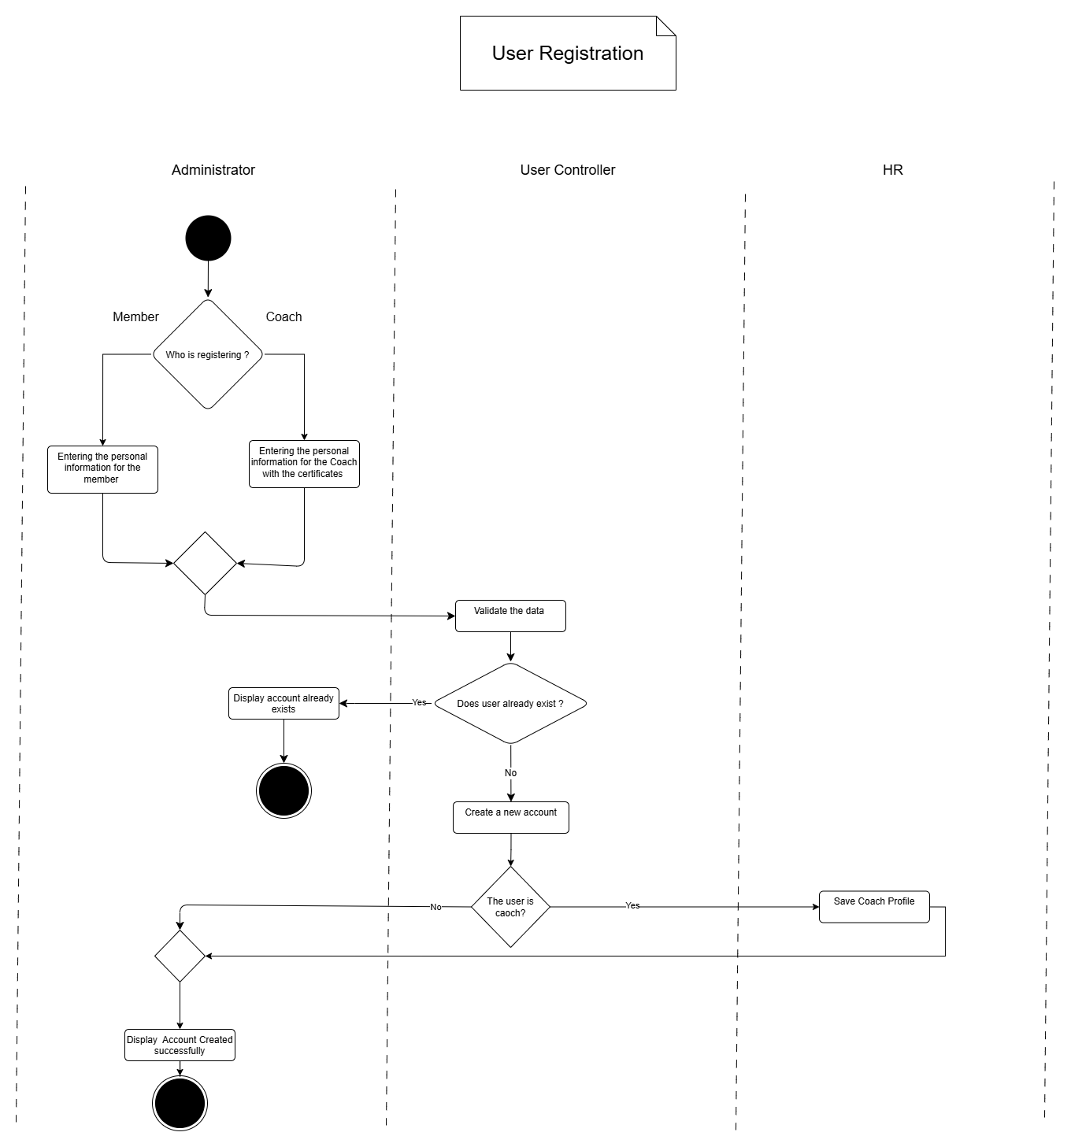

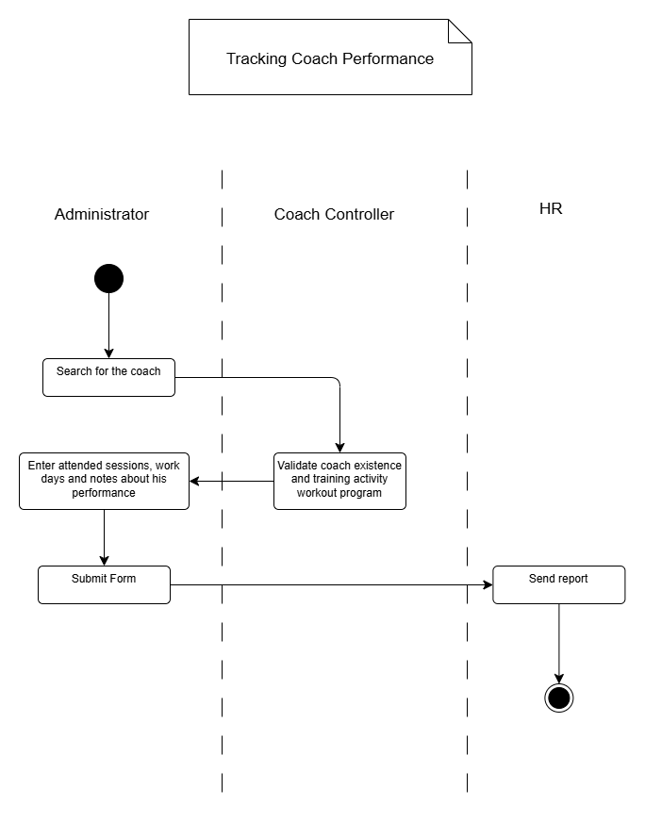

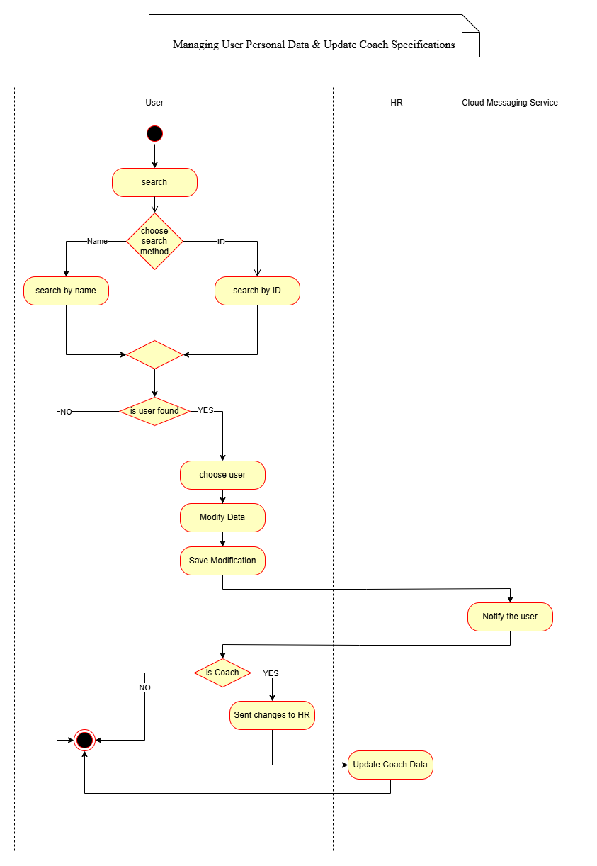

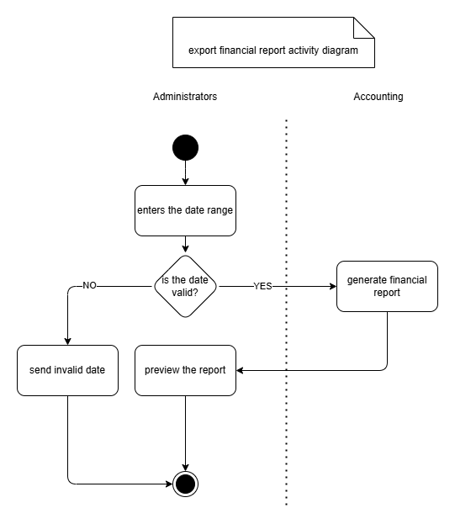

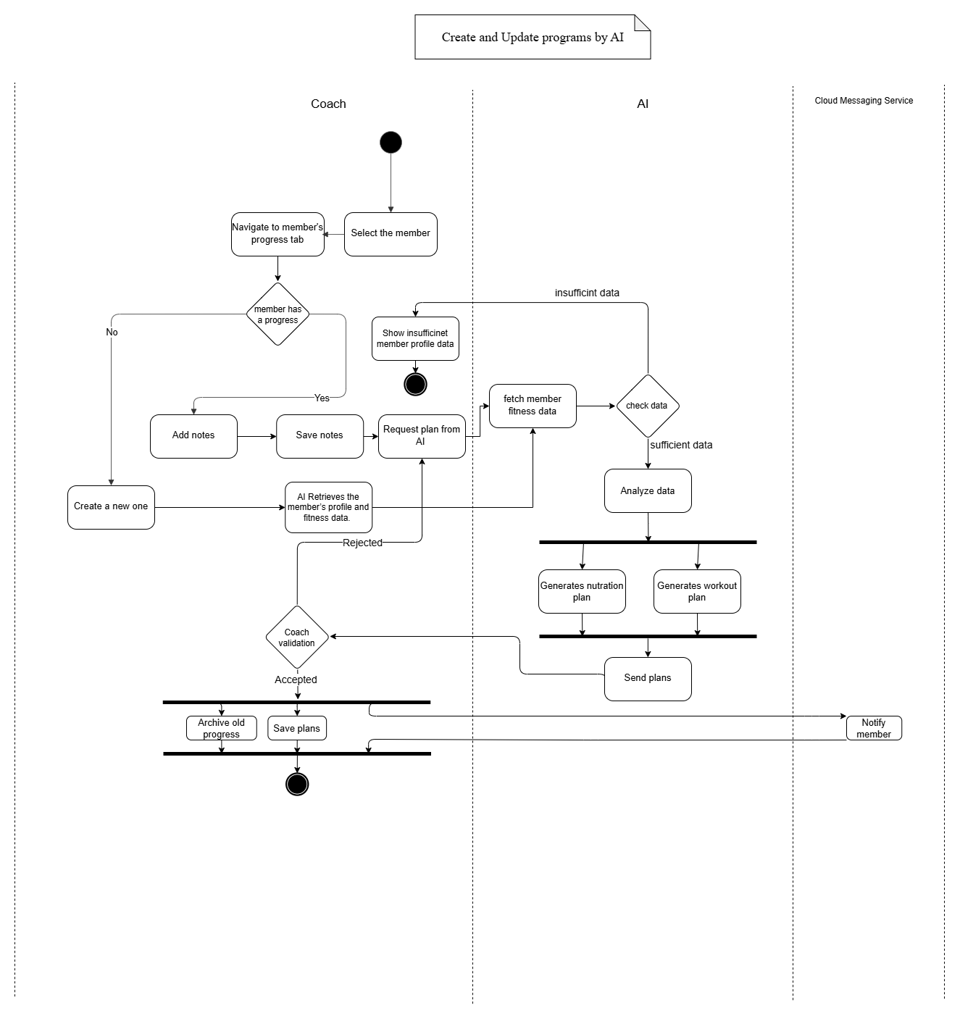

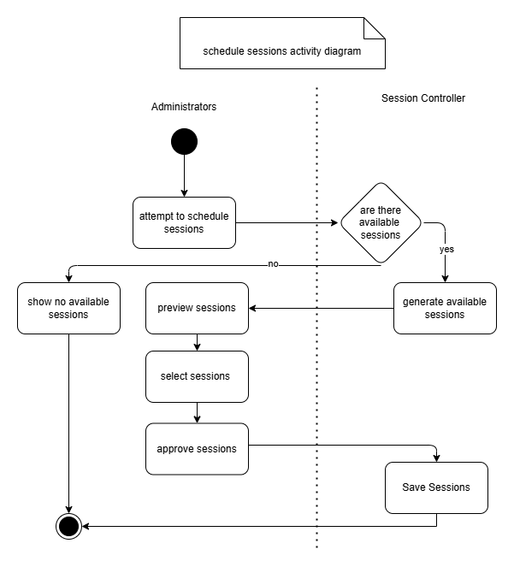

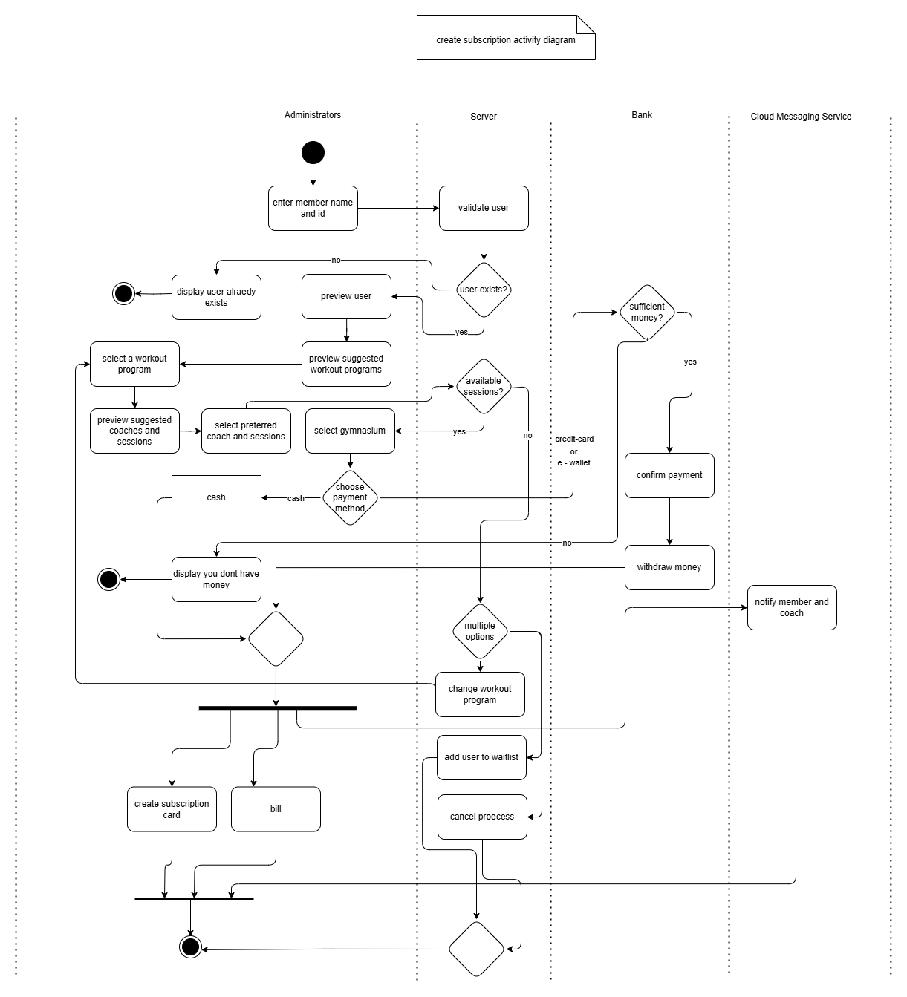

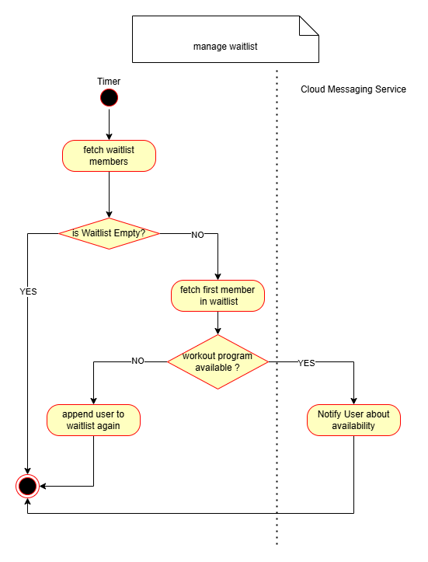

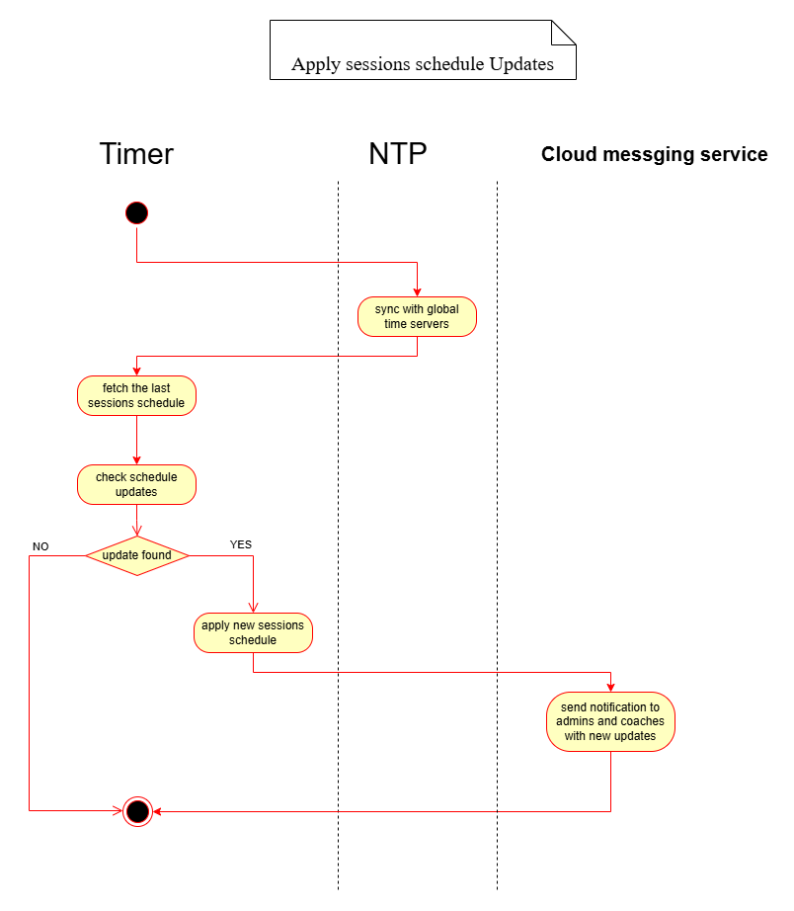

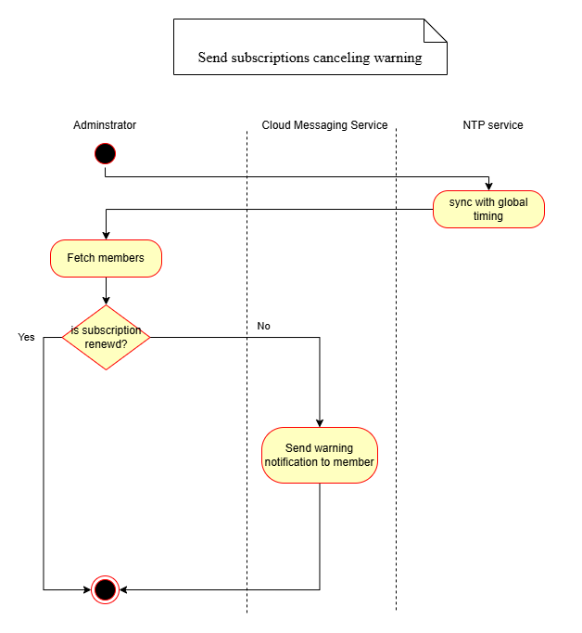

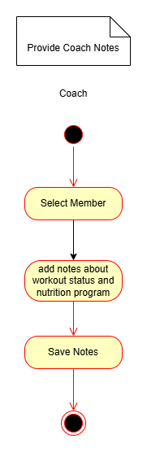

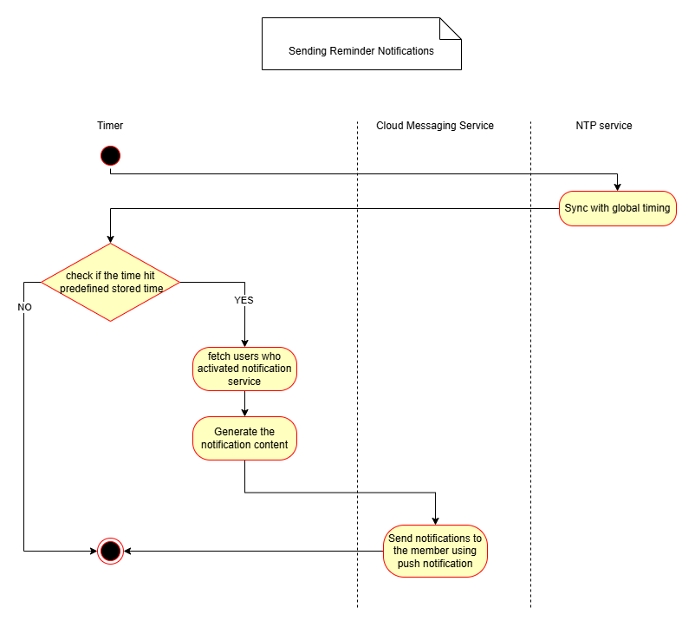

* 1. **Class Diagram:**

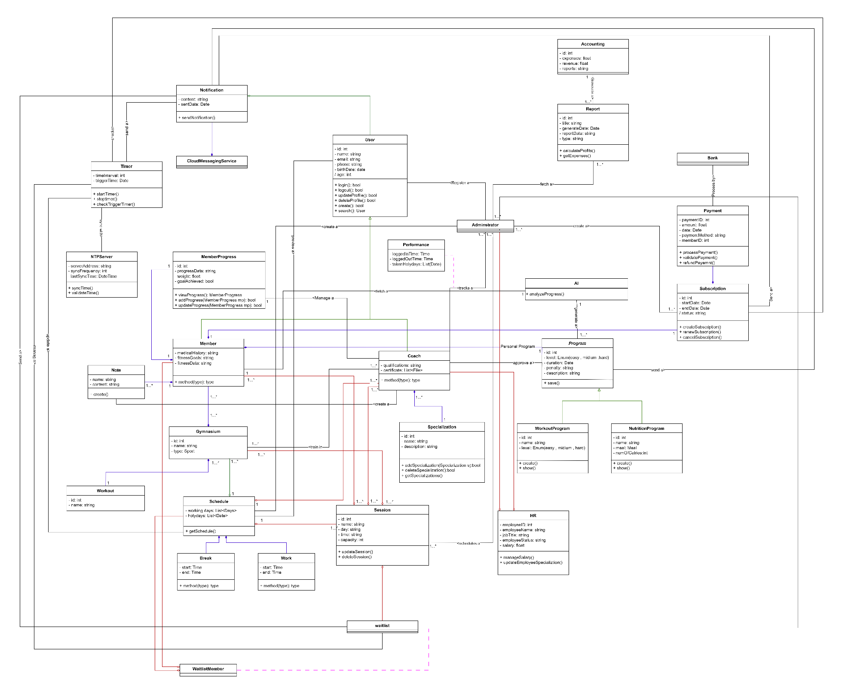

1. **Collaboration Diagrams:**

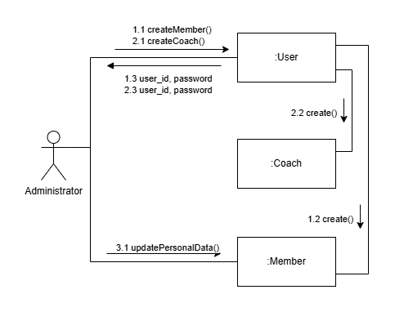

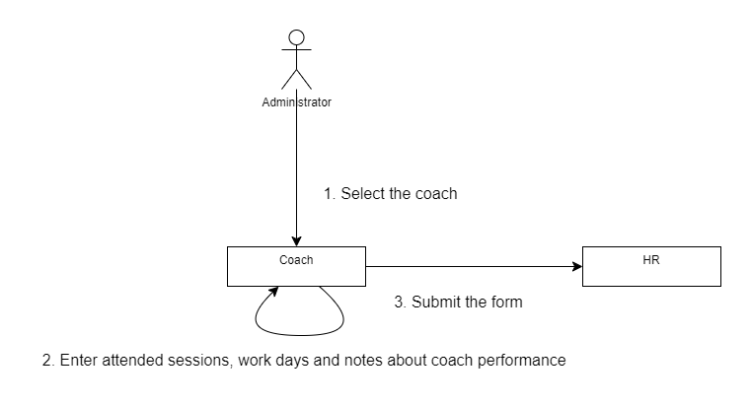

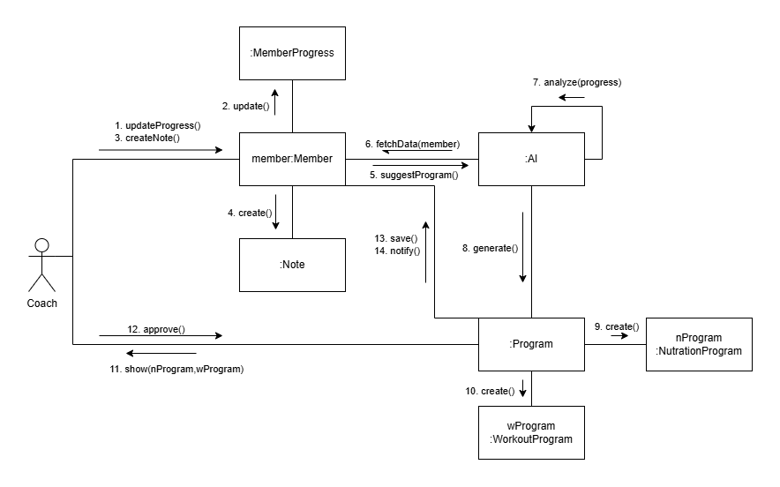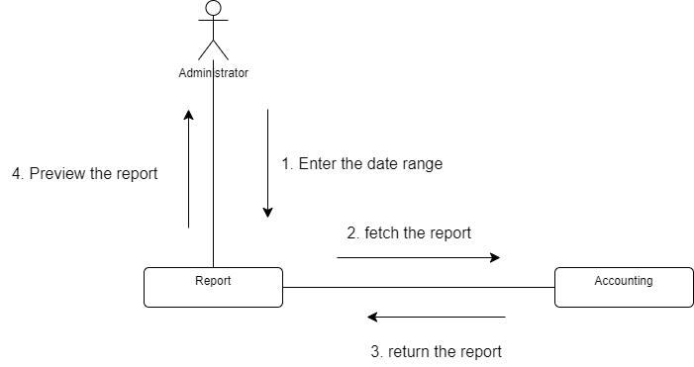

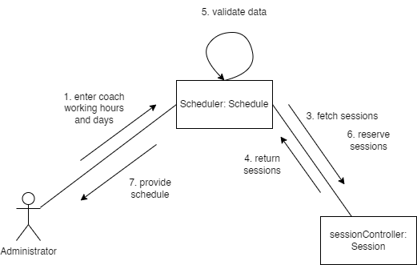

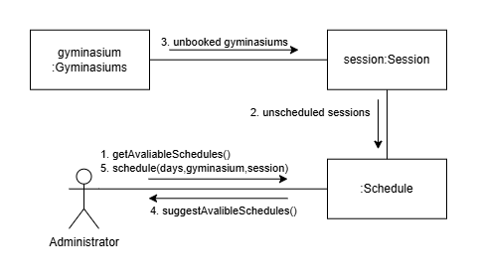

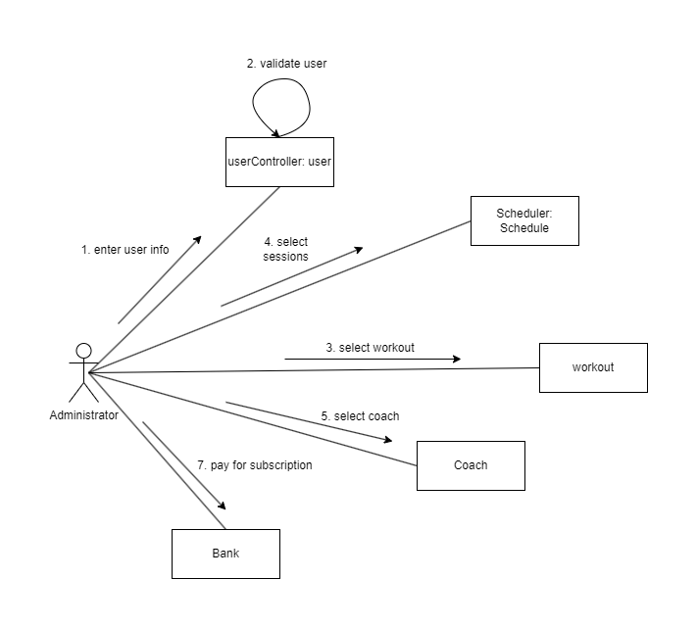

# Sequence Diagrams:

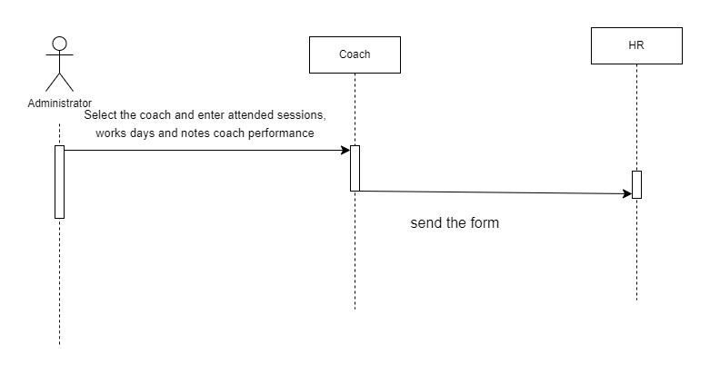

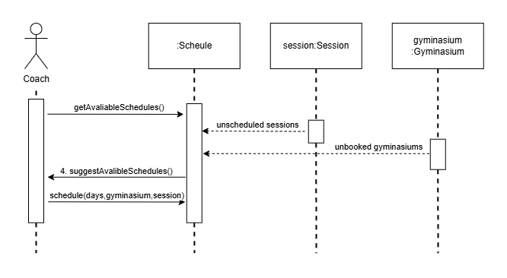

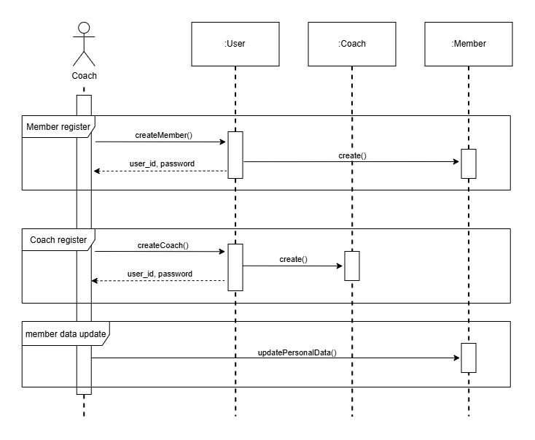

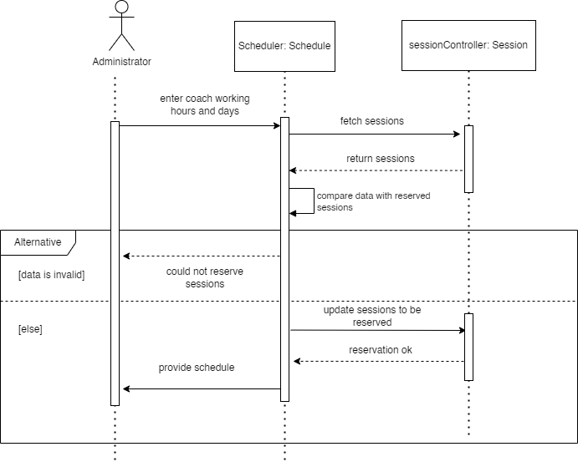

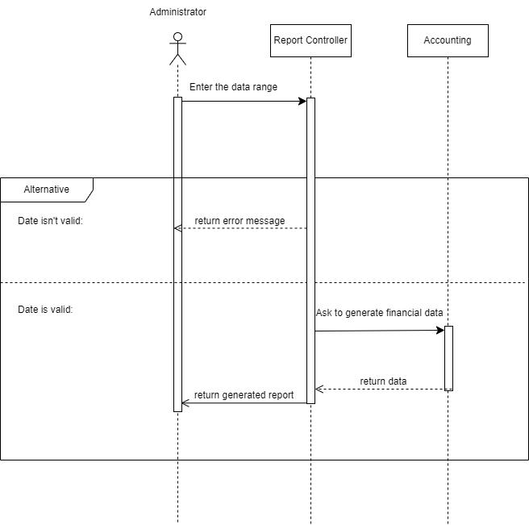

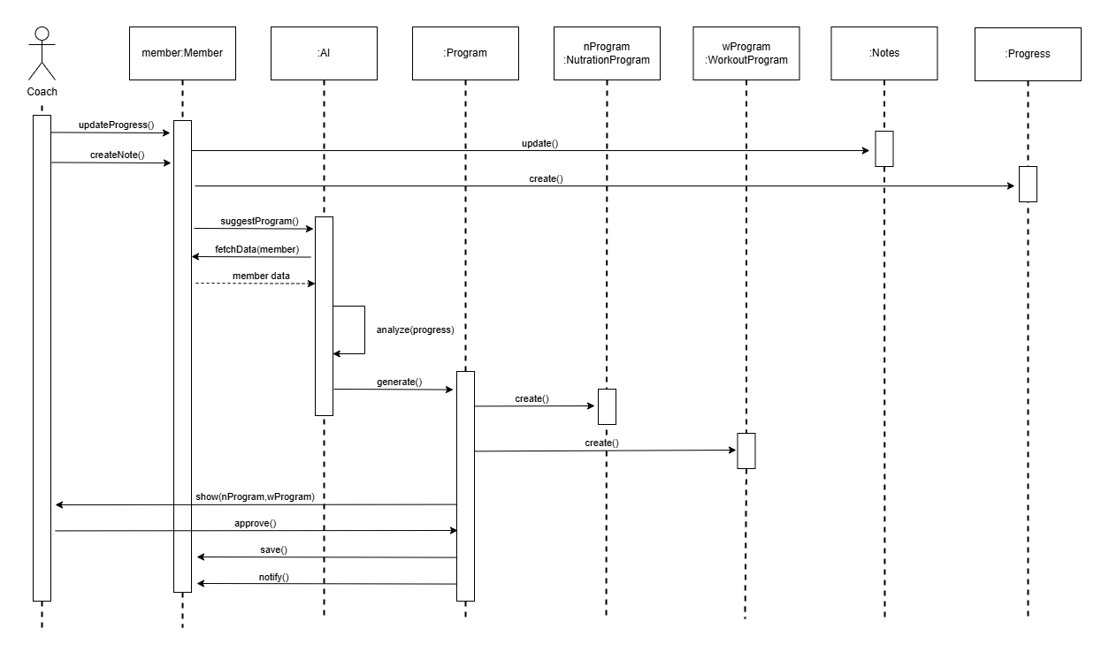

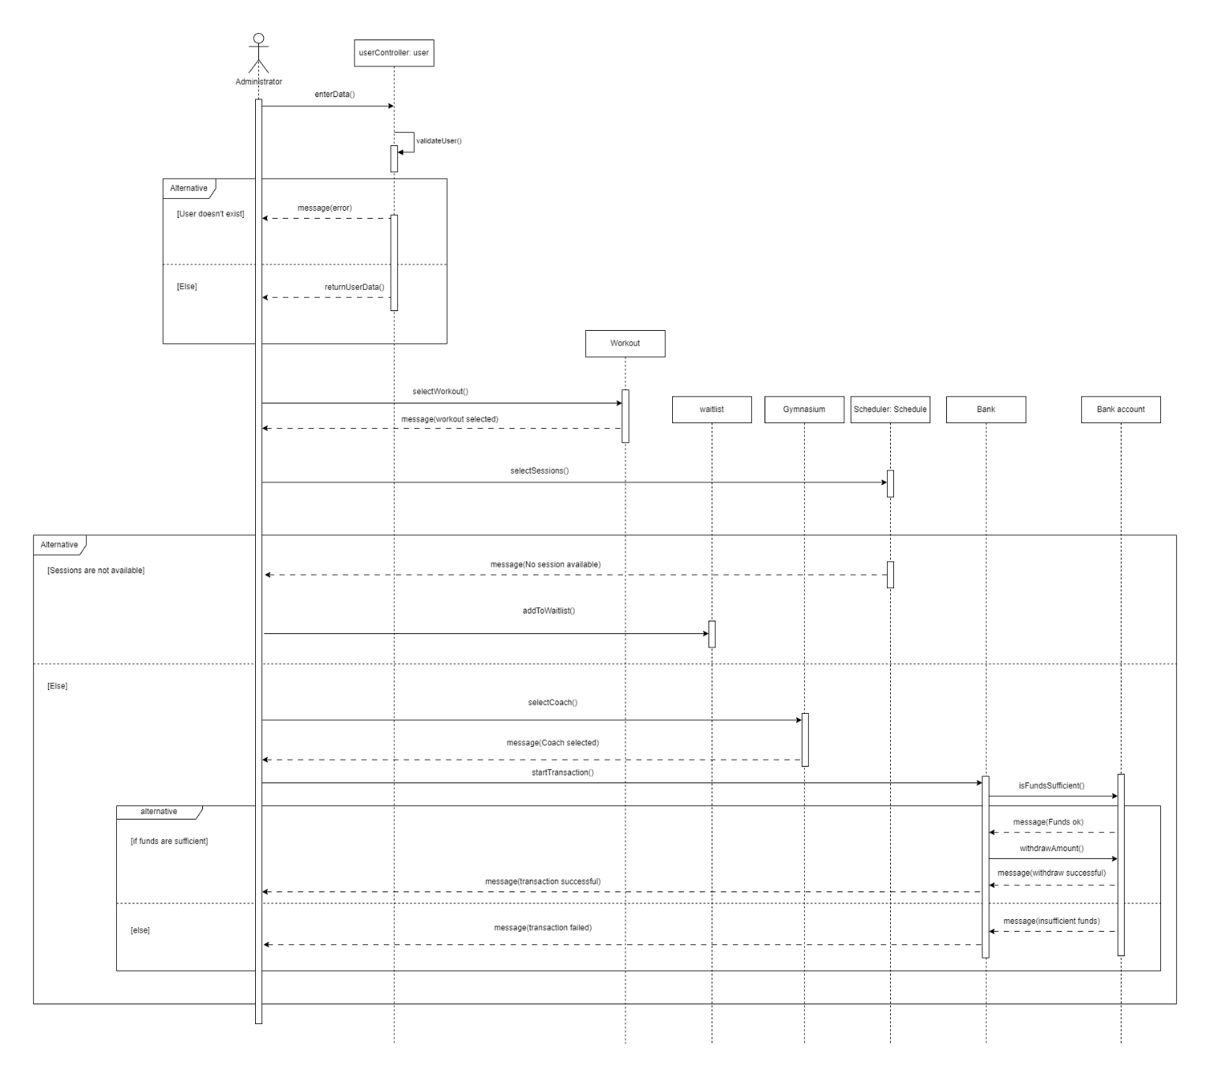

Coach

# State Diagrams:

